LEGISLATIVE TRAINING HANDBOOK
2019-2020

Table of Contents
Welcome 2
Overview 3
Senate Schedule 4,5
Executive Staff 6,7,8
Administrative Contacts 9
StudEx 10
Responsibilities of a Senator 11
Standing Committees 12
Legislative Process 13
Funding 14
Roberts Rules Summary 15,16,17
Chart of Motions 18,19

University of Kansas Student Senate
1301 Jayhawk Blvd, 410
Lawrence, KS 66045
Phone: 785-864-3710
Email: kusenate@ku.edu
www.studentsenate.ku.edu

Dear Senator,

For those of you returning, welcome back! For any new faces, welcome to the Student Senate. For the past 50 years, Student Senate has served as the fiercest advocate for student rights. Over the years, Student Senate has advocated for countless initiatives, rights, and regulations. The legacy of those before us is unmistakable, and you are now a part of that legacy.

Being a member of the Student Senate is a great privilege. With that privilege, comes a fair amount of responsibility. This guide is produced annually to lower the access barriers that exist in joining Student Senate. While this booklet is intended to be as thorough and descriptive as possible, it is by no means comprehensive. The best advice we can give is to utilize your resources. For years, the Student Senate office has operated on an open-door policy. This year is no different. Should you ever have questions or concerns, please reach out.

Over the coming year, we hope that you become an integral part of what makes this student government one of the best in the nation. Very few universities provide the level of autonomy to their student governance model that we receive here at the University of Kansas. The reason we are able to maintain this level of autonomy is through the effective and meaningful contributions of the Senators.

The past several years have been marked by numerous achievements, but there has also been a fair amount of apathy. Our hope for this year is that each and every Senator finds themselves with a purpose in Senate, as well as a cause they feel passionate about. Our doors are open, our ears are on, and our email inboxes are signed in. We are ready to be amazed by the great work that Senate can produce, and it starts with you!

May your journey as a Senator be full of opportunity, growth, and enjoyment.

Best,

Tiara Floyd Seth Wingerter Zach Thomason
Student Body President Student Body Vice President Chief of Staff

Overview

The University of Kansas Student Senate is one of the strongest student governments in the region and the nation. KU’s first form of student government was founded in 1909 and has seen a handful of structural changes to reach what it is today: a governing body with an 11-member executive branch, 105 Senators in its legislative branch, and a 5-member Court of Appeals.

Student Senate manages the allocation of over $20 million in student fees each year. These fees fund essential student services from the bus system and the University Daily Kansan, to Watkins Health Center and Ambler Student Recreation Center. Various boards and committees ran by Student Senate oversee the use of these fees and make recommendations for fee appropriation each year.

According to the University Senate Code (19.2), any policy-making committee at the college, school, program, or departmental level must have the number of students be “no less than 20 percent of the number of faculty members who hold the rank of instructor or above and who serve on the committee.” The Student Body President and Vice President make various appointments to these committees to ensure student representation throughout University affairs.

Student Senate is charged with many tasks: enhancing the learning experience inside and outside of the classroom; furthering the cultural, social, and political growth of KU students; ensuring equal learning opportunities to all students without exception; protecting student rights; increasing student input in University policy decisions; building a thriving University community; and representing KU students on the university, local, state, national, and international level. The opportunities we have as members of this body and as students at KU should not be taken lightly, and we all must seek to keep these goals and the greater good central to everything we do this year.

Student Senate: Fall 2019
 | Committees: August 28 |  |  |  |  |  | Finance: Alderson
 | **Meet @ 6 pm in Alderson for introduction |  |  |  |  |  | Rights: English Room
 | Full Senate: September 4 |  |  |  |  |  | Diversity, Equity, & Inclusion: OMA Classroom
 | First Cycle |  |  |  |  |  | University Affairs: Centennial Room
 | Legislative Deadline: Monday, August 26 @ 12 pm
 | Committees: September 11 |  |  |  |  |  | Finance: Alderson
 | Full Senate: September 18 |  |  |  |  |  | Rights: English Room
 | Second Cycle |  |  |  |  |  | Diversity, Equity, & Inclusion: OMA Classroom
 | Legislative Deadline: Friday, September 6 @ 5 pm |  |  |  |  |  | University Affairs: Centennial Room
 | Committees: September 25 |  |  |  |  |  | Finance: Alderson
 | Full Senate: October 2 |  |  |  |  |  | Rights: English Room
 | Third Cycle |  |  |  |  |  | Diversity, Equity, & Inclusion: OMA Classroom
 | Legislative Deadline: Friday, September 20 @ 5 pm |  |  |  |  |  | University Affairs: Centennial
 | Committees: October 9 |  |  |  |  |  | Finance: Alderson
 | Full Senate: October 16 |  |  |  |  |  | Rights: English Room
 | Fourth Cycle |  |  |  |  |  | Diversity, Equity, & Inclusion: OMA Classroom
 | Legislative Deadline: Friday, October 4 @ 5 pm |  |  |  |  |  | University Affairs: Centennial
 | Committees: October 23 |  |  |  |  |  | Finance: Alderson
 | Full Senate: October 30 |  |  |  |  |  | Rights: English Room
 | Fifth Cycle |  |  |  |  |  | Diversity, Equity, & Inclusion: OMA Classroom
 | Legislative Deadline: Friday, October 18 @ 5 pm |  |  |  |  |  | University Affairs: Centennial
 | Committees: November 6 |  |  |  |  |  | Finance: Alderson
 | Full Senate: November 13 |  |  |  |  |  | Rights: English Room
 | Sixth Cycle |  |  |  |  |  | Diversity, Equity, & Inclusion: OMA Classroom
 | Legislative Deadline: Friday, November 1 @ 5 pm |  |  |  |  |  | University Affairs: Centennial
 | Committees: November 20 |  |  |  |  |  | Finance: Alderson
 | Full Senate: December 4 |  |  |  |  |  | Rights: English Room
 | Seventh Cycle |  |  |  |  |  | Diversity, Equity, & Inclusion: OMA Classroom
 | Legislative Deadline: Friday, November 15 @ 5 pm |  |  |  |  |  | University Affairs: Centennial

Student Senate: Spring 2020
 | Committees: January 22 |  |  |  |  |  | Finance: Alderson
 | Full Senate: January 29 |  |  |  |  |  | Rights: English Room
 | Eighth Cycle |  |  |  |  |  | Diversity, Equity, & Inclusion: OMA Classroom
 | Legislative Deadline: Tuesday, January 21 @ 8 am |  |  |  |  |  | University Affairs: Centennial
 | Committees: February 5 |  |  |  |  |  | Finance: Alderson
 | Full Senate: February 12 |  |  |  |  |  | Rights: English Room
 | Ninth Cycle |  |  |  |  |  | Diversity, Equity, & Inclusion: OMA Classroom
 | Legislative Deadline: Friday, January 31 @ 5 pm |  |  |  |  |  | University Affairs: Centennial
 | Committees: February 19 |  |  |  |  |  | Finance: Alderson
 | Full Senate: February 26 |  |  |  |  |  | Rights: English Room
 | Tenth Cycle |  |  |  |  |  | Diversity, Equity, & Inclusion: OMA Classroom
 | Legislative Deadline: Friday, February 14 @ 5 pm |  |  |  |  |  | University Affairs: Centennial
 | Committees: March 4 |  |  |  |  |  | Finance: Alderson
 | Full Senate: March 18 |  |  |  |  |  | Rights: English Room
 | Eleventh Cycle |  |  |  |  |  | Diversity, Equity, & Inclusion: OMA Classroom
 | Legislative Deadline: Friday, February 28 @ 5 pm |  |  |  |  |  | University Affairs: Centennial
 | Committees: March 25 |  |  |  |  |  | Finance: Alderson
 | Full Senate: April 1 |  |  |  |  |  | Rights: English Room
 | Twelfth Cycle |  |  |  |  |  | Diversity, Equity, & Inclusion: OMA Classroom
 | Legislative Deadline: Friday, March 20 @ 5 pm |  |  |  |  |  | University Affairs: Centennial
 | Committees: April 15 |  |  |  |  |  | Finance: Alderson
 | Joint Senate: April 22 |  |  |  |  |  | Rights: English Room
 | No legislation will be seen |  |  |  |  |  | Diversity, Equity, & Inclusion: OMA Classroom
 |  |  |  |  |  |  | University Affairs: Centennial

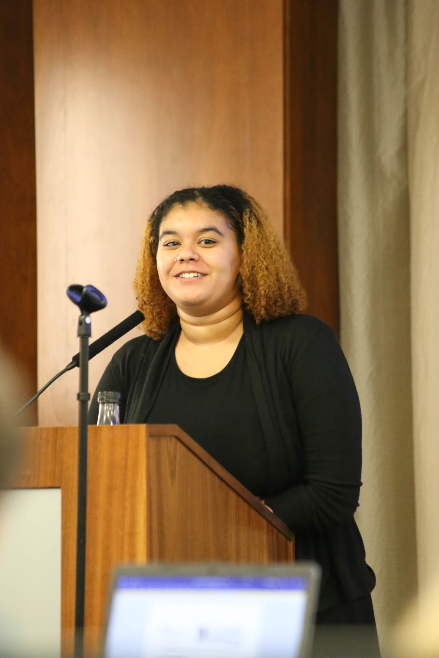
Executive Staff

Student Body President, Tiara Floyd: Tiara [ tee-air-uh ] Floyd (she/her/hers) is a senior from Junction City, Kansas studying African & African-American Studies with minors in Political Science and German. Tiara served as an on-campus senator, Chair of the DEI Committee, and Policy & Development before being elected as Student Body President. Tiara is also involved in Black Student Union and is an active member of Zeta Phi Beta Sorority, Inc. One of her biggest priorities for the year is that she can help make every student’s experience at KU meaningful while emphasizing the importance of inclusivity and affordability. ​

Student Body Vice President, Seth Wingerter: Seth Wingerter (he/him/his) is a senior from Olathe, KS majoring in Finance. Before serving as Student Body Vice President, some of Seth's roles in student governance included serving as a Holdover Senator and the Finance Committee Chair. Though his involvement with Finance Committee, he also served as Chair for the Campus Fee Review Subcommittee. During his time at KU, he has served in various leadership roles in Delta Sigma Pi Business fraternity and as president of Phi Gamma Delta. Seth is excited to help be the voice for all on campus and wants to make the expansion of mental health services offered to students a priority during his term.

Chief of Staff, Zach Thomason: Zach Thomason (he/him/his) is a junior from Leawood, Kansas majoring in Business Analytics and Accounting with a minor in Spanish and a concentration in International Business. During his time in Senate, Zach has served as both a freshman and Business Senator, University Senate Executive Committee as well as the former Chair of both University Affairs and Student Senate Outreach. Zach is currently serving his second term as Chief of Staff and serves on Legal Services for Students Advisory Board, Memorial Corporation Board, and Transit Advisory Board and is chair of Senate Alumni Relations Board.

Policy and Development Director, Isabella Southwick: Isabella Southwick (she/her/hers) is a junior from San Francisco, California majoring in Political Science with minors in Sociology and Public Policy. Before serving on executive staff, Isabella served as a freshman/sophomore College of Liberal Arts and Sciences senator. Isabella has served on the Memorial Corporation Board as well as Student Health Advisory Board during the last school year. In the past two years at the University of Kansas, Isabella became an active member of Alpha Delta Pi and worked at the Boys and Girls Club of Lawrence.

Communications Director, Liza Overton: Liza [ lye-zuh ] Overton (she/her/hers) is a senior from St. Charles, Missouri studying pharmaceutical science on the Pre-Law track. Before serving as the Communications Director for Student Senate, Liza was a Pharmacy Student Senator and Chair of Student Health Advisory Board for Watkins Health Center. She also currently serves on the Budget & Tuition Advisory Committee and Outreach Board. While at KU, Liza has been involved with Kappa Psi Pharmaceutical Fraternity, Student National Pharmaceutical Association, ResearchRX, and is a Pi Beta Phi Alumnae.

Treasurer, Furqan Mohammed: Furqan [ fur-con ] Mohammed (he/him/his) is a junior from Overland Park, Kansas. He is on the pre-med track majoring in Business Administration and Analytics. Before serving on Executive Staff, Furqan was the Assistant Treasurer, freshman/sophomore College of Liberal Arts and Sciences senator and Freshmen Intern. He has also served on the Transit Committee, Student Safety Board, Student Health Advisory Board, and Elections Code Subcommittee.

Assistant Treasurer, Sam Reinig: Sam Reinig (he/him/his) is a sophomore Finance and Business Analytics Major from Overland Park, Kansas. He served as an off campus senator before taking on the role of Assistant Treasurer and has gotten involved with the School of Business through the Business Leadership Program. In his free time, Sam is an active member of his fraternity and an intramural sports competitor.

Director of Diversity and Inclusion, Mercedeh Tavacoli: Mercedeh [mer-say-duh ] Tavacoli (she/her/hers) is a senior from Overland Park, Kansas and is on the pre-med track majoring in Microbiology with minors in Psychology and Spanish. Mercedeh has been involved with Student Senate for the last 3 years and served as a College of Liberal Arts & Sciences Senator, Diversity, Equity & Inclusion associate senator, and DEI Committee Secretary. She has also been involved with Student Health Advisory Board, Elections Code Subcommittee, Transit Commission, and Equal Opportunity Fund during her time with Senate.

Government Relations Director, Grant Daily: Grant Daily (he/him/his) is a junior from Wichita, Kansas triple majoring in International Studies, History, and Economics. Before his time as Government Relations Director, Grant held several positions across campus ranging from working with low income student groups to representing undergraduates on University Senate. While serving in this position, Grant hopes to create a more inclusive environment and increase student's voice at all levels of government. He has also been a member of the Dole Institute Student Advisory Board and worked as a research assistant for both the Biology and Sociology Departments.

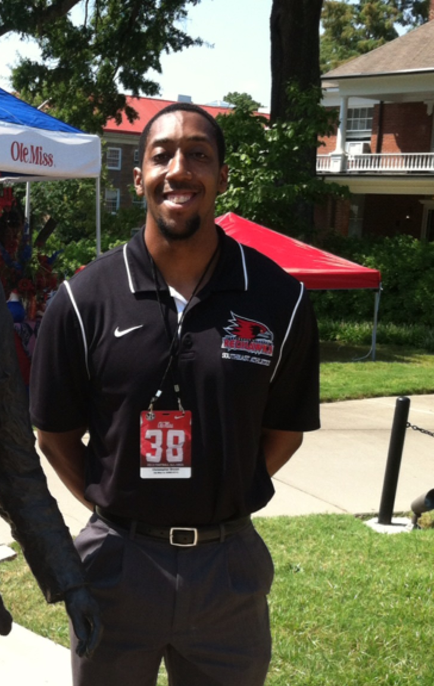

Graduate Student Body Vice President, Chris Brown: Chris Brown (he/him/his) is a Graduate Student studying Sport Management. In addition to being the Graduate Student Body Vice President, Chris also serves as a Graduate Teaching Assistant at KU. Prior to his time at the University of Kansas, Chris worked as the Associate Director of Academic and Membership Affairs for the NCAA, as well as the Assistant Director of Compliance at Southeast Missouri State University. Chris completed his undergraduate work at Colorado State University. This is Chris’ first year in Senate.

Director of Internal Affairs, Addison Henson: Addison Henson (she/her/hers) is a sophomore from Kansas City, Missouri studying Information Systems Technology. During her time in Student Senate, Addison has served as a freshman and Business Senator and University Senate member. She has also been on a number of committees including University Core Curriculum, Student Rights Representative for the Fee Review Subcommittee, Budget and Tuition Advisory Committee, and an Initiatives Intern. Outside of senate, Addison is an active member of Sigma Kappa and is involved with the University

Administrative Contacts
Sabine Jones, Student Senate Staff Assistant: As the Staff Assistant, Sabine assists the daily needs of the Student Senate Executives, the Center for Community Outreach, as well as student organizations needing assistance in navigating Student Senate processes. Prior to joining Student Senate she worked in Provost Business Services, Office of Diversity, Equity, & Inclusion, Multicultural Resource Center and Public Administration Department. Sabine is starting her 17th year with KU. In her free time she enjoys spending time with her family and friends and her dog Teddy. She enjoys working on art, photography, and reading.

Marsha Carrasco, Director, Student Involvement and Leadership Center: Marsha oversees a broad swath of programming affecting student life. SILC facilitates Greek Life, Leadership & Education trainings, and nontraditional student services. She serves as an advisor to the executive branch of Senate, primarily the Chief of Staff through her role as advisor to Senate and StudEx.

Dr. Tammara Durham, Dean of Undergraduate Studies & Vice Provost for Student Affairs: Durham is the senior student affairs officer at the Lawrence campus. Within her role as Vice Provost for Student Affairs, she directs student life, support, and leadership programs. In her relationship with Student Senate, she serves as the advisor to the executive branch, primarily the President and Vice President.

Student Executive Committee (StudEx)

The Student Executive Committee meets once per legislative cycle and is charged with approving the schedule and agenda for full Senate, tracking board attendance, office policy enforcement, line item funding changes, and serving as a compromise committee to reconcile conflicting amendments made by standing committees. StudEx may be called into session over the summer to address time-sensitive issues when full Senate is not in session.

The Chief of Staff chairs StudEx and the committee is comprised of:

10 voting members: President, Vice President, Graduate Student Body Vice President, Diversity, Equity, and Inclusion Chair, Rights Chair, Finance Chair, University Affairs Chair, SenEx senators (3).

7 non-voting ex-oficio members: Treasurer, Assistant Treasurer, Communications Director, Director of Diversity and Inclusion, Director of Internal Affairs, Government Relations Director and Development Director.

Chief of Staff can vote to make or break a tie.

Responsibilities as a Senator

Attendance Policy (SSRR Article I)
- All undergraduate student senators are to attend all Student Senate and committee.
- Regulations for Graduate-level senators require 3 full senates and 2 committees.
  - If a senator is not able to attend a Student Senate meeting, s/he must notify the Student Senate Executive Secretary prior to that meeting. If a senator is not able to attend a committee meeting, s/he must notify the Committee Secretary as well as the Student Senate Executive Secretary prior to that meeting.
  - An absence will be excused for the following reasons: family emergencies, religious holidays, substantial illness, job interviews or tests. All other reasons will be considered during StudEx.
- Attendance will be recorded on a semester basis. Missing beginning or ending roll call shall count as one-half (1/2) absence. If StudEx deems appropriate, the Chief of Staff shall remove any senator who has received two (2) unexcused absences or three (3) absences of any kind per semester. StudEx shall determine whether extenuating circumstances allow for an excused absence, even if SSRR calls for it to be listed as unexcused. The Communications Director will notify all delinquent senators by e-mail and by written notification in their mailbox at least one week prior to the next StudEx meeting.

Office Hour Policy/Outreach Policy

- Outreach is required at the start of each semester. This is satisfied by contacting your assigned student organizations.
- Beginning this year, office hours are no longer required. The Executive Staff has historically had a difficult time effectively tracking office hours, and the consensus is that they create artificial outreach means. In the event that outreach declines dramatically, a new policy will be drafted, but the hope is that Senator’s find the intrinsic initiative to engage with Senate activities, legislation, and student organizations.

Standing Committees

Each Student Senator is required to be a member of one of the four standing committees. Attendance requirements are the same as full Senate meetings.
(Graduate, Law, Non-traditional, and Pharmacy students are required to attend at least two (2) committee meetings per semester to fulfill their committee meeting requirements.)

If a senator is not able to attend a committee meeting, she or he must notify the Committee Secretary as well as the Student Senate Internal Affairs Director prior to that meeting.

The committees are as follows:

Student Rights: The overseer of Student Senate Rules and Regulations, the University Code, and the Code of Student Rights and Responsibilities. Often consults with Legal Services for Students and the Office of Student Affairs. It sees all proposed changes to SSRR.

Diversity, Equity, and Inclusion: This committee exists to carry out diversity, equity, and inclusion emphasis of Student Senate. It addresses issues of discrimination, the diversity, equity, and inclusion concerns of those students not in the majority at KU or the surrounding community, and KU’s policies for the recruitment, retention, and services provided for marginalized student populations.

Finance: The Finance Committee reviews all legislation authorizing expenditures from the Student Senate activity fund and oversees KU student fees. It also monitors and recommends changes to funding guidelines within SSRR.

University Affairs: This committee deals with issues that directly involve aspects of student life and campus programming. It may review questions regarding the policy, organization, and functions of student services at the University.

Legislative Process

- A senator has an idea for a bill, or a student group requests funding.
- Discuss collaboration with other senators if so desired.
- Use the template on the Student Senate website under “Documents & Records.”
  - Email the bill to the Chief of Staff (senatecos@ku.edu) by the legislative deadline (usually Friday after full senate by 5 pm)
- COS will format the bill; VP will assign it to committees.
- Each bill will be debated in committees; can pass, fail, table, or postpone each bill.
  - Committees can also make amendments.
  - Only bills that pass all committees to which they were referred can be seen in full senate.
  - StudEx will reconcile any conflicting amendments.
- Full Senate debates each bill; can also pass, fail, table, or postpone.
- Passing legislation takes effect when the Student Body President signs it, or after 10 days if SBP declines to sign.
  - SBP can issue a statement of disapproval and refuse to sign.
  - Said statement is debated at next full Senate; two-thirds majority can vote to enact legislation notwithstanding SBP’s disapproval.

Funding

Student Senate has three primary funding sources: Block, Line-item, and the Unallocated account. The budget code is in Article VIII of SSRR. The Block and Line-item process happens in the spring semester around the same time as Fee Review; and week-to-week funding requests come from Unallocated.

Guidelines for funding

- To qualify for funding, a student group must:
  - Be open to all KU students
  - Be registered with SILC
  - Have no academic standards or membership dues
- Any group requesting a service fee (honorarium, DJ fee, etc) must turn in a contractual services form and W9 before the legislation can be passed
- For special events, refer to the “half-over-a-thousand” rule: Senate can fund up to the first $1,000 of the cost and 50% of the remaining total
- Groups seeking more than general funding ($100) should send representatives to help answer questions in committees and full senate
- Groups should seek funding from other sources, such as Coke program funding, Multicultural Education Fund, and departmental support
- Funds will be available for groups 10 days after approval, at the earliest. Groups should therefore be seeking event funding earlier rather than later
- Article VIII, Section 5 of SSRR has a comprehensive list of restrictions – please convey this information to groups before submitting a bill to reduce the risk of a bill being ruled out of order or being greatly amended
- Compliance does not guarantee passage. All bills are subject to debate and all senators are obligated to participate fully in the conversation, keeping in mind that the Unallocated account is limited
- Student Organizations that fail to comply with regulations and complete the acknowledgement form may be sanctioned by StudEx

Roberts Rules Summary
A. Quorum:
A quorum is the minimum number of members who must be present at a meeting for business to be legally transacted.
An organization, in its established rules, may define its own quorum.
In the absence of such a provision, the quorum is a majority of the entire membership.
B. Obtaining the Floor:
Before a member in an assembly can make a motion or speak in debate, he or she must obtain the floor; that is, the member must be recognized by the chair as having the exclusive right to be heard at that time. If two or more members rise to seek recognition at the same time, the member who rose and addressed the chair first after the floor was yielded is usually entitled to be recognized. A member cannot establish "prior claim" to the floor by rising before it has been yielded.
C. Introducing Business (Making Motions):
Business may be introduced by an individual member or by a committee. Business is always introduced in the form of a motion.
D. Seconding a Motion:
- After a motion has been made, another member, without rising and obtaining the floor, may second the motion.
- A second merely implies that the seconder agrees that the motion should come before the assembly and not that he or she necessarily favors the motion.
- A motion made by a committee requires no second, since its introduction into the assembly has been approved by a majority of the committee.
- The purpose of a second is to prevent time from being consumed by the assembly having to dispose of a motion that only one person wants to see introduced.
E. Placing a Motion Before the Assembly:
- After a motion has been made and seconded, the chair repeats the motion verbatim, thus placing it before the assembly for debate and action.
- During the brief interval between the making of a motion and the time when the chair places it before the assembly by restating it, the maker of a motion may modify or withdraw it simply by stating the intention to do so.
- After the motion has been restated by the chair, it is officially before the assembly and must be dealt with appropriately (e.g., adopted, rejected, postponed).
F. Debate:
- Every member of the assembly has the right to speak on every debatable motion before it is finally acted upon; this right cannot be interfered with except by a motion to limit debate.
- All discussion must be confined to the immediately pending question and to whether or not it should be adopted.
- While debate is in progress, amendments or other secondary motions can be introduced and disposed of accordingly.
- In an organization that has no special rule relating to the length of speeches, a member can speak no longer than 10 minutes unless he or she obtains the consent of the assembly; such permission can be given by unanimous consent or by means of a motion to extend debate. Likewise, debate may be curtailed by a motion to limit debate.
- No member may speak twice on the same motion at the same meeting as long as any other member who has not spoken on the motion desires to do so.
- Unless the rules are suspended, a member who has spoken twice on a particular question on the same day has exhausted his or her right to debate that question for that day.
- During debate, no member can attack or question the motives of another member.
- The maker of a motion, although allowed to vote against it, is not allowed to speak against it.
G. Amendments:
- As noted above, before a motion has been restated by the chair, the maker has the right to modify his or her motion or to withdraw it entirely. After it has been restated by the chair, however, a motion may be modified only by means of an amendment.
- There are six ways to amend a motion: a. Add words, phrases, or sentences at the end of a motion; b. Insert words, phrases, or sentences; c. Strike words, phrases, or sentences; d. Strike and insert words, phrases, or sentences; e. Strike and add words, phrases, or sentences; and f. Substitute whole paragraphs or an entire text.
- Only two amendments (primary and secondary) may be pending on a main motion at any time.
- Discussion of an amendment must relate only to the amendment, unless the whole motion is involved by substitution.
- An amendment must be germane to the question under consideration.
H. Voting:
- Unless special rules apply, a majority decides. A majority is more than half of the votes cast by persons legally entitled to vote, excluding blank ballots or abstentions.
- Unless otherwise provided for, voting is by voice vote.
- If the presiding officer is a member of the assembly, he or she can vote as any other member does when the vote is by ballot. In other cases, the presiding officer, if a member of the assembly, can ( but is not obliged to ) vote whenever his or her vote will affect the result; i.e., he or she can vote either to break or to create a tie.
- A member has no right to explain his or her vote" during voting since that would be the same as debate at such a time.
- Any member may request a division of the assembly if there is uncertainty as to the true result of the vote.
I. Announcing a Vote:
- In announcing the vote on a motion, the chair should: a. report on the voting itself, stating which side has prevailed; b. declare that the motion is adopted or lost; c. state the effect of the vote or order its execution.
- For a voice or rising vote in which no exact count is taken, the chair might say, for example, "The ayes have it, the motion carries, and the brochure will be published." For a vote in which an exact count is taken, the chair might say, "There are 14 in the affirmative and 15 in the negative. The negative has it and the motion is lost. No additional funds will be spent on publicity this semester."
J. Adjournment:
- A motion to adjourn may be made by any member. It may be made during the consideration of other business, although it may not interrupt a speaker.
- A motion to adjourn is not in order when the assembly is engaged in voting or verifying a vote.
- If the motion to adjourn is voted down, it may be made again only after the disposition of some business.
- The motion to adjourn is out of order when the assembly is arranging for the time and place of the next meeting.
- When it appears that there is no further business to be brought before the assembly, the chair, instead of waiting for a motion, may simply adjourn the meeting.

Source: http://www.yourparliamentarian.com/Summary.htm

Robert's Rules of Order Motions Chart
RobertsRules.org
Part 1, Main Motions. These motions are listed in order of precedence. A motion can be introduced if it is higher on the chart than the pending motion.
§ indicates the section from Robert's Rules.
§ | PURPOSE: | YOU SAY: | INTERRUPT? | 2ND? | DEBATE? | AMEND? | VOTE?
§21 | Close meeting | I move to adjourn | No | Yes | No | No | Majority
§20 | Take break | I move to recess for ... | No | Yes | No | Yes | Majority
§19 | Register complaint | I rise to a question of privilege | Yes | No | No | No | None
§18 | Make follow agenda | I call for the orders of the day | Yes | No | No | No | None
§17 | Lay aside temporarily | I move to lay the question on the table | No | Yes | No | No | Majority
§16 | Close debate | I move the previous question | No | Yes | No | No | 2/3
§15 | Limit or extend debate | I move that debate be limited to ... | No | Yes | No | Yes | 2/3
§14 | Postpone to a certain time | I move to postpone the motion to ... | No | Yes | Yes | Yes | Majority
§13 | Refer to committee | I move to refer the motion to ... | No | Yes | Yes | Yes | Majority
§12 | Modify wording of motion | I move to amend the motion by ... | No | Yes | Yes | Yes | Majority
§11 | Kill main motion | I move that the motion be postponed indefinitely | No | Yes | Yes | No | Majority
§10 | Bring business before assembly (a main motion) | I move that [or "to"] ... | No | Yes | Yes | Yes | Majority

Part 2, Incidental Motions. No order of precedence. These motions arise incidentally and are decided immediately.
§ | PURPOSE: | YOU SAY: | INTERRUPT? | 2ND? | DEBATE? | AMEND? | VOTE?
§23 | Enforce rules | Point of Order | Yes | No | No | No | None
§24 | Submit matter to assembly | I appeal from the decision of the chair | Yes | Yes | Varies | No | Majority
§25 | Suspend rules | I move to suspend the rules | No | Yes | No | No | 2/3
§26 | Avoid main motion altogether | I object to the consideration of the question | Yes | No | No | No | 2/3
§27 | Divide motion | I move to divide the question | No | Yes | No | Yes | Majority
§29 | Demand a rising vote | I move for a rising vote | Yes | No | No | No | None
§33 | Parliamentary law question | Parliamentary inquiry | Yes | No | No | No | None
§33 | Request for information | Point of information | Yes | No | No | No | None

Part 3, Motions That Bring a Question Again Before the Assembly.
No order of precedence. Introduce only when nothing else is pending.
§ | PURPOSE: | YOU SAY: | INTERRUPT? | 2ND? | DEBATE? | AMEND? | VOTE?
§34 | Take matter from table | I move to take from the table ... | No | Yes | No | No | Majority
§35 | Cancel previous action | I move to rescind ... | No | Yes | Yes | Yes | 2/3 or Majority with notice
§37 | Reconsider motion | I move to reconsider ... | No | Yes | Varies | No | Majority

